1. Create BaseEntity class

**(a).** Mark class with **@MappedSuperclass** & **@EntityListners(AuditingEntityListner.class)**

**(b). As required mark columns with respective annotations (@CreatedDate, @CreatedBy,   
 @LastModifiedDate & @LastmodifiedBy)**

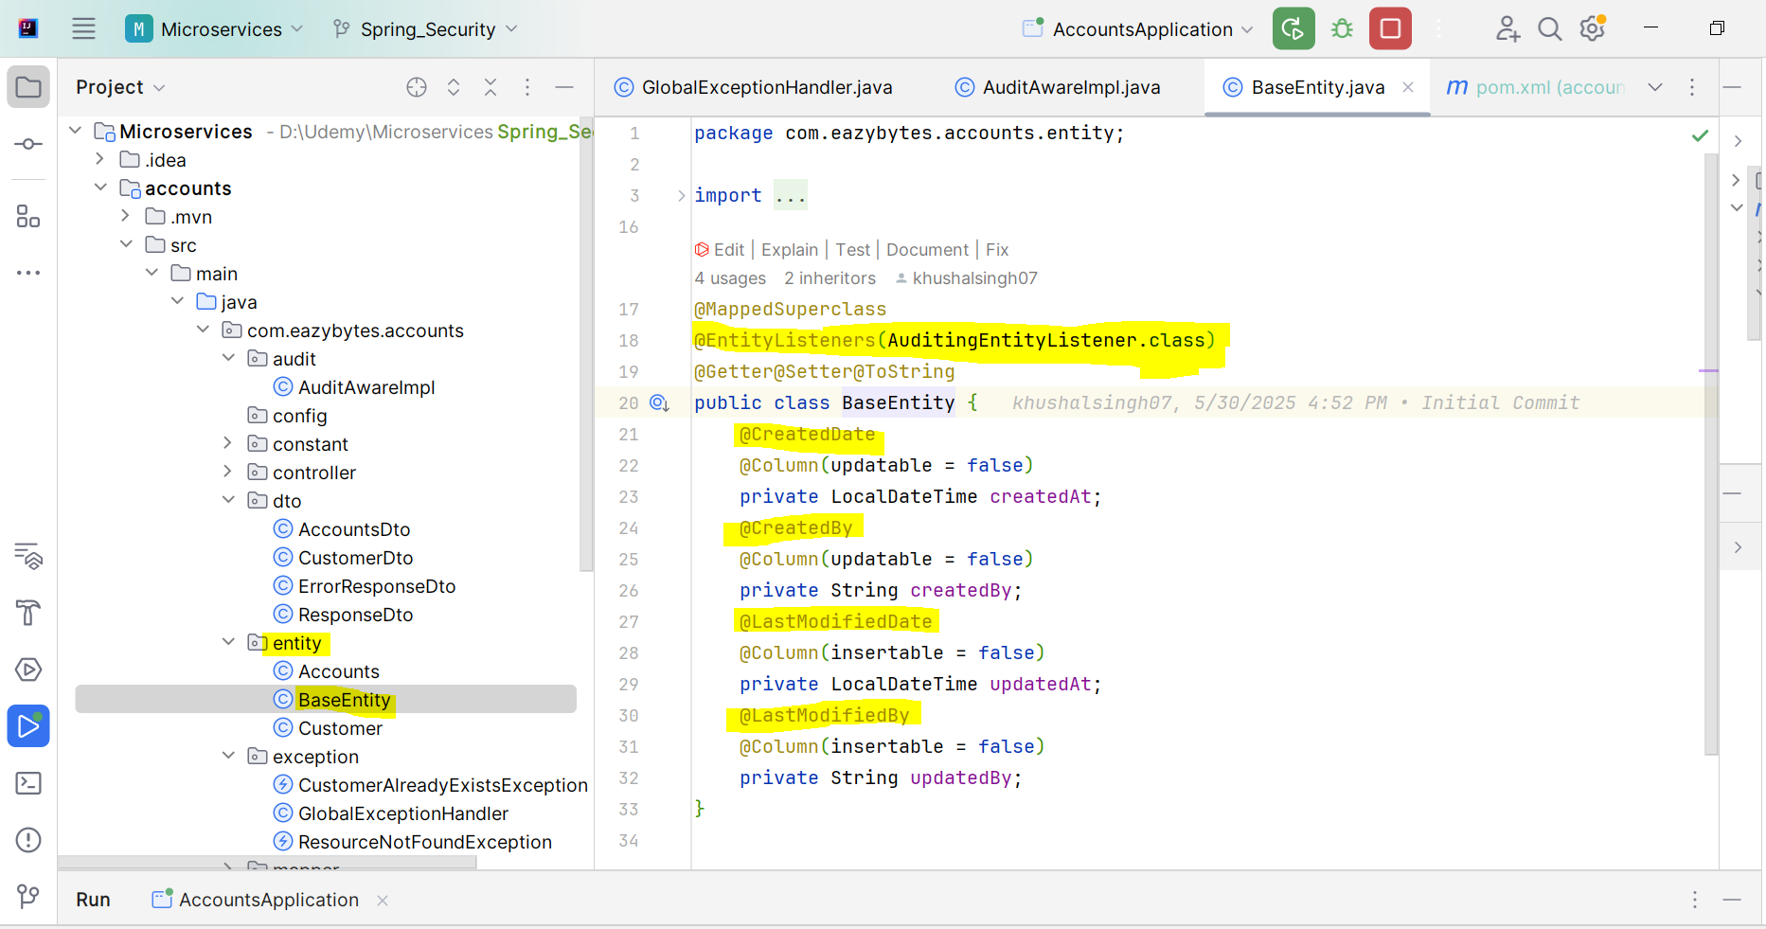

2. To get the value **Created By** and **Last Updated By**

Create a class **AuditAwareImpl** and **annotated with @Component(“auditAwareImpl”)** and   
 implement with **AuditorAware<String>** and implements a method **getCurrentAuditor()**

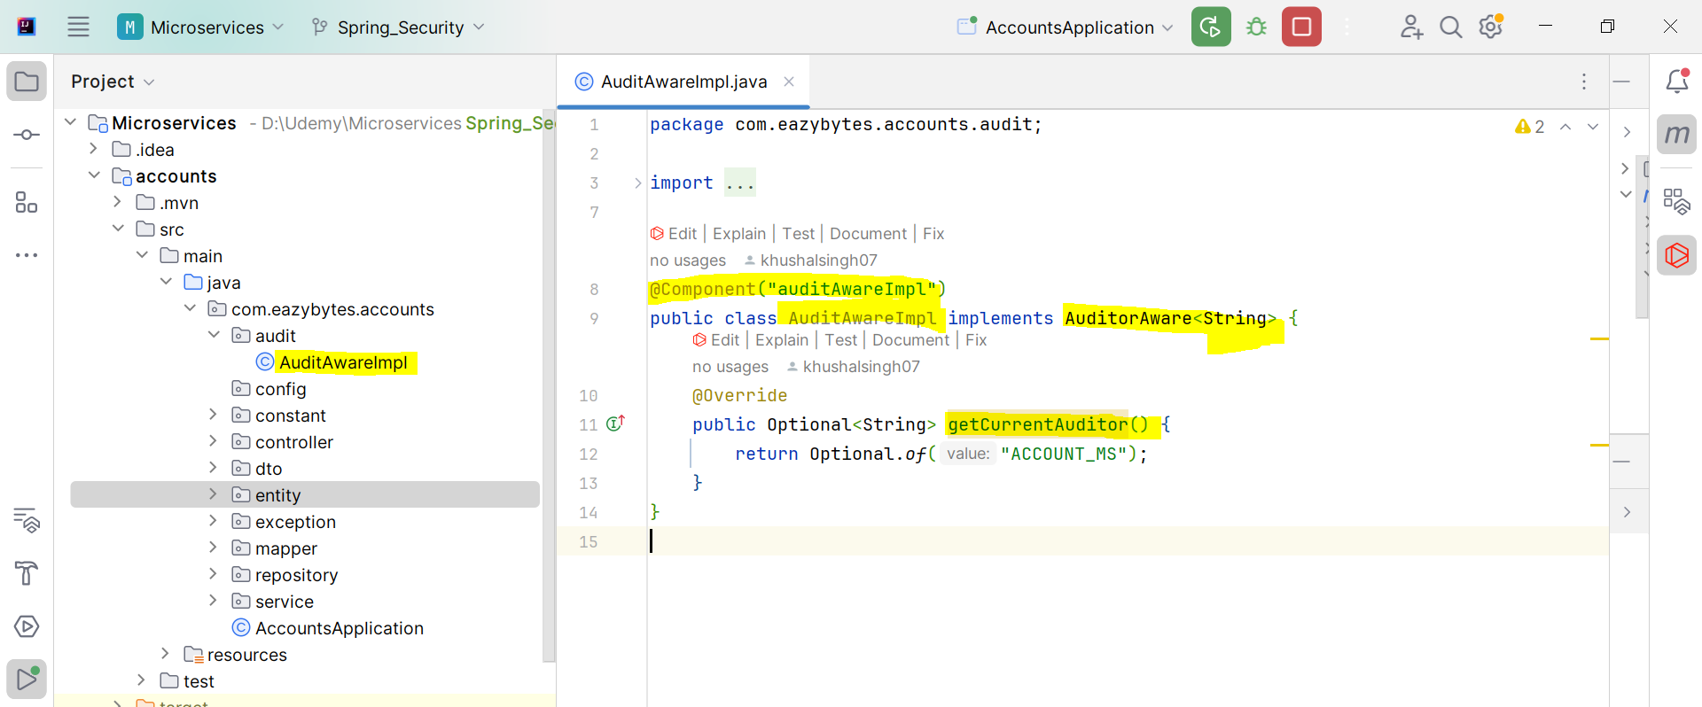

3. Annotated the main class with **@EnableJPAAuditing(auditAwareRef = “auditAwareImpl”)**

